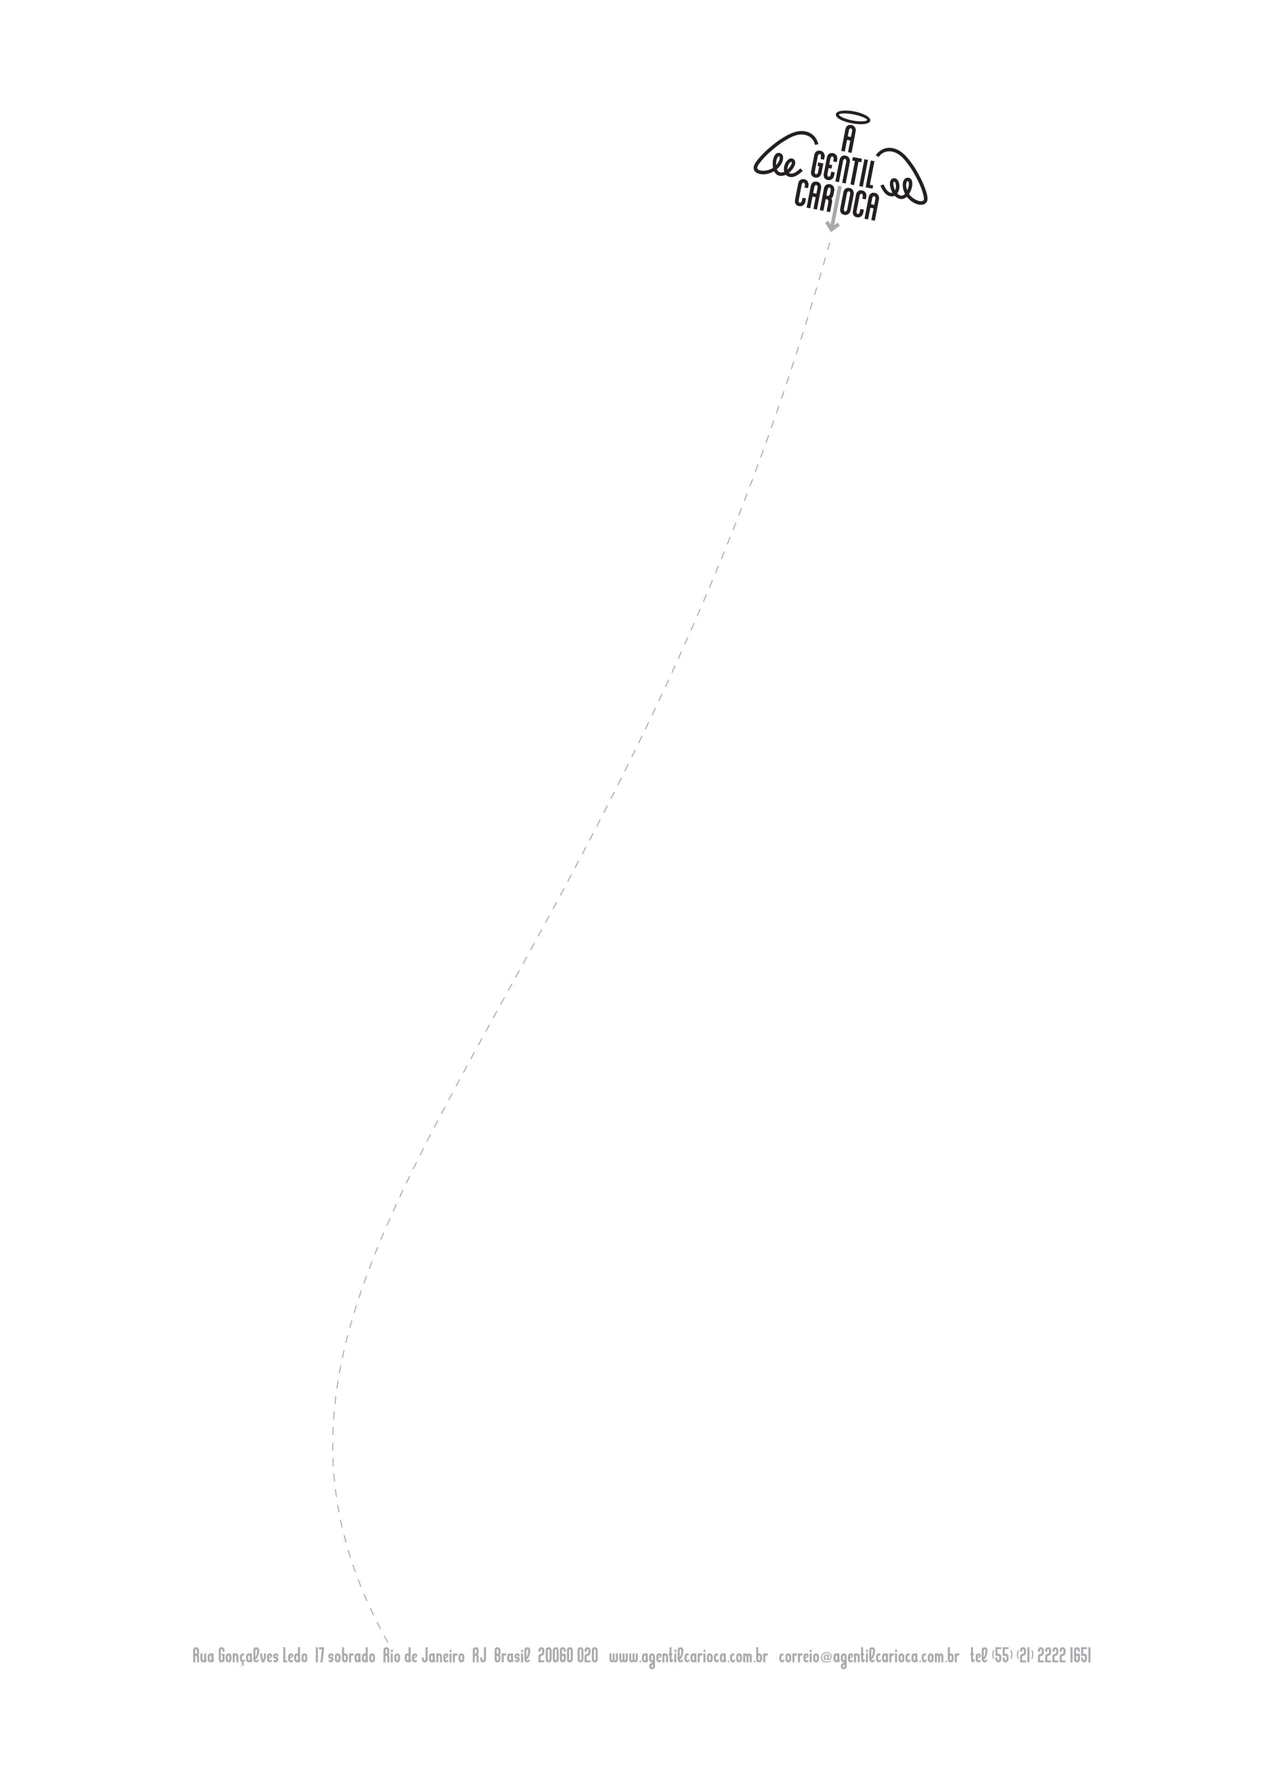

PRESS RELEASE

Abertura da Exposição | Exhibition Opening MAPAS TEMPORAIS DE UMATERRA NÃO SEDIMENTADA, Thiago Rocha Pitta

Lançamento Camisa Educação nº 68 | Education T-SHIRT nº 68 Leonardo Lobão / Ateliê Gaia / Museo Bispo do Rosário Arte Contemporânea

Gentil Parede XÔ DOR por Lenora de Barros| Gentle Wall XÔ DOR by Lenora de Barros
Apoio Gentil TBA21 Collection| Gentil Support TBA21 Collection
A GENTIL CARIOCA 13° Aniversário | 13th Birthday Party
Bolo Escultura por Edmilson Nunes | Cake/Sculpture by Edmilson Nunes
Musica/ Performance/ Poesia Projeto 4 Quina | Music/ Performance/ Poetry Projeto 4Quina
Participação Grupo Bixin Bodega | Special guest Grupo Bixin Bodega
abertura | opening 03.09.2016
de 18hs às 22hs | 06pm to 10pm

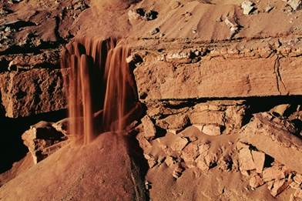

exposição | exhibition 05.09 a 08.10.2016
seg a sex 12hs às 19hs | mon to fri 12pm to 07pm
sáb com agendamento | sat under appointment

THIAGO ROCHA PITTA
TEMPORARY MAPS OF A NON-SEDIMENTED LAND

In his fourth solo show at the A Gentil Carioca gallery Thiago Rocha Pitta exhibits frescos and videos from the Temporary maps of a non-sedimented land series, work in which we see the independent development, except for minor interventions from the artist, of various movements of eroded and varied terrain. These records are characteristic of the artist's work which encourages observation and reflection on natural elements.

A graduate in painting from the School of Fine Arts at UFRJ in 2003, he attended several free courses at the School of Visual Arts (EAV) at Parque Lage. Some of his works are in museum collections such as the MoMA in New York, Thyssen-Bornemisza Art Contemporary in Vienna and the Hara Museum in Tokyo.

The exhibition also includes The Gentil Wall by the artist Lenora de Barros presenting her work XÔ DOR and the launch of the 68th edition of the Education T-shirt by Leonardo Lobão (Atelier Gaia / Museu Bispo do Rosário Arte Contemporânea).
During the opening of the exhibition A Gentil Carioca will also celebrate its 13th birthday alongside the always present partners, friends, collectors and art lovers in general that have always, and increasingly, follow the gallery’s remarkable cultural trajectory.

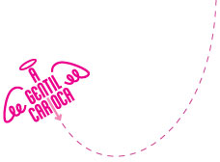

THIAGO ROCHA PITTA

Mapas temporais de uma terra não sedimentada

Temporary maps of a non-sedimented land
Abertura 03/09/2016 18h - 22h
Opening Sept 3, 2016 6pm - 10pm

Education T-SHIRT number 68 by Leonardo Lobão / Atelier Gaia / Museu Bispo do Rosário Arte Contemporânea
Gentle Wall XÔ DOR by Lenora de Barros
from September 3rd to January 7th
Gentil Support TBA21Collection
A GENTIL CARIOCA 13th Birthday Party
Cake/Sculpture by Edmilson Nunes
Music/ Performance/ Poetry Projeto 4 Quina
Exhibition from September 5th to October 26th

 | Share
 | Tweet
 | Forward

Barroca, 2012. Palácio Capanema, RJ
Desktop I, 2008

